

TRIBHUVAN UNIVERSITY
FACULTY OF HUMANITIES AND SOCIAL SCIENCE

A Project Report
On
Artmandu- "A Virtual Art Showcase"

Submitted to
Department of Computer Application
National College of Computer Studies

In partial fulfillment of the requirements for Bachelor in Computer Application

Submitted By:
Sujal Maharjan
Roll: 6-2-551-51-2021

Under the Supervision of
Teksan Gharti Magar


Tribhuvan University
Faculty of Humanities and Social Sciences National College of Computer Studies

SUPERVISOR’S RECOMMENDATION

We hereby recommend that this project prepared under my supervision by Sujal Maharjan entitled "Artmandu - A Virtual Art Showcase” in partial fulfillment of the requirements for the degree of Bachelor of Computer Application is recommended for the final evaluation.

……………………………….
SIGNATURE
Teksan Gharti Magar
SUPERVISOR
Faculty Member
Department of Computer Application
National College of Computer Studies


Tribhuvan University
Faculty of Humanities and Social Sciences National College of Computer Studies

LETTER OF APPROVAL

This is to certify that this project prepared by Sujal Maharjan entitled "Artmandu - A Virtual Art Showcase” in partial fulfillment of the requirements for the degree of Bachelor in Computer Application has been evaluated. In our opinion it is satisfactory in the scope and quality as a project for the required degree.

SIGNATURE of Supervisor  Teksan Gharti Magar  Faculty Member  Department of Computer Application  National College of Computer Studies Paknajol, Kathmandu | SIGNATURE of HOD/ Coordinator  MR .Rajan Poudel  Faculty Member  Department of Computer Application  National College of Computer Studies Paknajol, Kathmandu
SIGNATURE of Internal Examiner | SIGNATURE of External Examiner

Abstract
This project proposes the development of an online art gallery to showcase and enquire about artwork from various artists around the world. The aim is to provide a platform for artists to showcase their work and for art enthusiasts to discover art easily. The platform will feature a user-friendly interface and offer various search and filter options to help users navigate through the collection. The recommendation systems helps to suggest relevant pieces based on user preferences. The proposed online art gallery has the potential to revolutionize the art market by providing a global platform for artists and collectors alike. This platform will facilitate direct and secure transactions, allowing art enthusiasts to purchase artworks seamlessly while ensuring transparency and fair pricing. By bridging the gap between creators and art lovers, the online gallery has the potential to transform the traditional art marketplace into a more inclusive and dynamic digital space. This platform aims to foster a vibrant community that supports artistic expression, promotes cultural exchange, and drives innovation in how art is discovered and shared worldwide.
Keywords: online art gallery, artists, artwork, platform, search, recommendation systems.

Acknowledgement
I would like to thank my supervisor Mr. Teksan Gharti Magar for his valuable guidance who gave me great encouragement for this work and helpful suggestions.
I would also like to thank our Vice Principal sir, Mr. Santosh Maskey who monitored, guided and motivated us throughout all the phases of this project. I appreciate the support from all the supervisors, friends and family to help make this project successfully.
Sujal Maharjan

Table of Contents
Abstract iv
Acknowledgement v
List of Abbreviations viii
Table of Figures ix
Table of Figures x
Chapter 1 Introduction 1
1.1 Introduction 1
1.2 Problem Statement 1
1.3 Objectives 1
1.4 Scope and Limitation 2
1.4.1 Scopes 2
1.4.2 Limitation 2
1.5 Development Methodology 2
1.6 Report Organization 3
Chapter 2 Background Study and Literature Review 5
2.1 Background Study 5
2.2 Literature Review 5
Chapter 3 System Analysis and Design 7
3.1 System analysis 7
3.1.1 Requirement Analysis 7
i. Functional Requirements 7
ii. Non-Functional Requirements 8
3.1.2 Feasibility Analysis 9
3.1.3 Data Modeling 10
3.1.4 Process Modeling 11
3.2 System Design 13
3.2.1 Architectural Design 13
3.2.2 Database Schema 14
3.2.3 Interface design (UI/UX) 15
3.2.4 Physical DFD 16
3.3 Algorithm Details 17
Chapter 4 Implementation and Testing 19
4.1 Tools and Technology used 19
4.1.1 Front End Technology 19
4.1.2 Back End Technology 19
4.1.3 Tools 19
4.2 Module Description 20
4.3 Testing 22
4.3.1 Unit Testing 22
4.3.2 System Testing 23
Chapter 5 Conclusion and Recommendation 25
5.1 Conclusion 25
5.2 Lesson learnt 25
5.3 Future Recommendation 25
Reference 27

List of Abbreviations
API - Application Programming Interface
CSS - Cascading Style Sheets
HTML - Hypertext Markup Language
JS - JavaScript
MS Word - Microsoft Word
PHP - Hypertext Preprocessor
RDBMS - Relational Database Management System
VS Code - Visual Studio Code
XAMPP - X-operating system, Apache, MySQL, Php, Perl

Table of Figures
Figure 1.1 waterfall Methodology of GalleryNest 2
Figure 3.1 Use case diagram of GalleryNest 7
Figure 3.2 ER diagram of GalleryNest 11
Figure 3.3 DFD level 0 11
Figure 3.4 DFD Level 1 12
Figure 3.5 System Architecture Design 13
Figure 3.6 Database Schema of GalleryNest 14
Figure 3.7 Interface Design of GalleryNest 15
Figure 3.8: Physical DFD of GalleryNest 16

Introduction

Introduction
The purpose of this proposal is to outline the concept and strategy for an online art gallery that will serve as a platform for artists and art enthusiasts to showcase, view and purchase art pieces. The objective of this project is to establish a successful online art gallery that provides artists with a platform to exhibit and sell their work to a global audience. The benefits of an online art gallery application include accessibility to a wider audience, reduced overhead costs for artists and buyers, and the convenience of purchasing art from the comfort of one's own home. Additionally, it allows for greater exposure and recognition for emerging artists who may not have access to traditional gallery spaces. It provides a virtual space for artists to display their work and for buyers to browse art from anywhere in the world.

Problem Statement
In the country where the online art gallery project is being launched, many talented artists are not getting the recognition they deserve. Due to limited opportunities to showcase their art, they struggle to make a living from their work and find it difficult to connect with potential buyers and patrons. This has led to a situation where the country's art scene is not as vibrant and diverse as it could be, with many talented artists going unnoticed and their work unseen.
The lack of recognition and support for artists is a significant problem that needs to be addressed. The online art gallery project aims to tackle this issue by providing a platform for artists to showcase their work to a global audience, offering a range of resources and tools to help artists develop their careers, and promoting the country's art scene and culture to a wider audience. The gallery hopes to create a sustainable and equitable art ecosystem that supports artists and helps them reach their full potential, while also promoting the country's unique artistic heritage and culture.

Objectives
- To provide informative content, artist profiles, and descriptions of artworks.
- To Encouraging the appreciation of art.
- To support emerging artists by giving them a platform to gain recognition.

Scope and Limitation

Scopes
- The application can provide a platform for emerging artists to showcase their work and gain recognition.
- The application can allow for easy transactions, such as purchases and commissions, through secure online payment systems.
- Users can easily browse through the gallery and search for specific types of art using filters and categories.

Limitation
- The application may face competition from other online art marketplaces, making it challenging to attract artists and customers.
- The cost of maintaining and developing the application can be high, especially for features such as secure payment systems and marketing campaigns.

Development Methodology
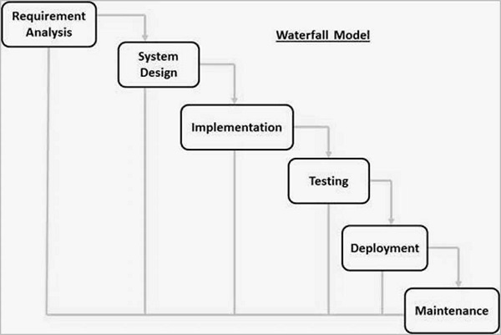
Figure 1.1 waterfall Methodology of GalleryNest
Development Methodology for an Online Art Gallery Project using Waterfall Model:
The Waterfall model is a linear and sequential approach that emphasizes a clear and structured progression through the phases of development. It is suitable for projects where requirements are well-understood and unlikely to change significantly during the development process.
In the Waterfall model, each phase must be completed before the next phase begins, ensuring a thorough and methodical approach to project development.
The following are the key phases of the Waterfall model that will be used in developing the online art gallery project:
- Requirements Phase: In this phase, the project requirements are defined and documented. This includes understanding the needs of the users and stakeholders and ensuring all requirements are clear and unambiguous.

- Design Phase: In this phase, the project team develops the overall design of the online art gallery system. This involves creating detailed architectural designs, user interfaces, and database schemas

- Implementation Phase: In this phase, the actual coding and development of the system take place. The system components are built according to the design specifications.

- Testing Phase: In this phase, the system undergoes rigorous testing to ensure it meets the project requirements and functions as intended. This includes unit testing, integration testing, and user acceptance testing.

- Deployment Phase: In this phase, the system is deployed to the live environment. This involves setting up the necessary infrastructure and ensuring the system is ready for use by the end-users.

- Maintenance Phase: In this phase, the system is monitored and maintained to ensure it continues to function correctly. Any issues or bugs identified are fixed, and updates are made as necessary.
In conclusion, the Waterfall model is a suitable development methodology for an academic project to develop an online art gallery system. It provides a clear and structured approach, ensuring each phase is thoroughly completed before moving on to the next.

Report Organization
Chapter 1: Introduction
The introduction of the 'online art gallery' sets the stage by providing an overview of the project. It introduces the concept and purpose of the online art gallery application, highlighting the problem it aims to address. This problem statement could be the lack of a reliable platform for artists to showcase their work and for art enthusiasts to discover and purchase art.
Chapter 2: Background study and Literature Review
In this chapter, a comprehensive analysis of existing models similar to the online art gallery is conducted. The review compares these models with the current project's goals, features, and uniqueness.
Chapter 3: System Analysis and Design
Chapter 3 offers a detailed overview of the system design. It includes architectural diagrams or models that illustrate how different components of the online art gallery interact
Chapter 4: Implementation and Testing
Chapter 4 explains the technical aspects of the project. It elaborates on the tools used for both the front-end (user interface) and back-end (database, server, etc.). The choice of programming languages, frameworks, and technologies is discussed, along with their purpose in the project.
Chapter 5: Conclusion and Future Recommendations
The conclusion chapter sums up the accomplishments of the project and the findings that were made during its development. It provides a recap of how the project successfully met its objectives and addressed the initial problem. The conclusion could also touch on lessons learned and challenges faced during the project.

Background Study and Literature Review

Background Study
An online art gallery is a virtual platform that offered a dynamic space where diverse artworks can be showcased and explored from anywhere in the world. The gallery will provide a platform for artists to showcase their work to a global audience and offer a range of resources and tools to help artists develop their careers. Visitors to the gallery will be able to browse and purchase artwork, learn more about the country's art scene and culture, and discover new artists and works of art. Beyond the presentation of artworks, the project takes on an ambitious role as an ambassador of the country's art scene and cultural heritage.
The driving force behind this endeavor is a group of founders whose passion for art and equity propels their commitment to creating an ecosystem that is not only artist-centric but also sustainable and just. The gallery's visionary founders recognize the power of art in fostering cross-cultural connections and aspire to craft an environment that champions diversity, creativity, and opportunity. The platform affords visitors the opportunity to immerse themselves in an array of artworks, engage with the narratives behind the creations, and even acquire pieces that resonate with them.
In conclusion, the online art gallery project stands as a testament to the potential of technology to dismantle geographical barriers and elevate artists to a global stage. By doing so, it not only elevates individual artists but also elevates the country's cultural landscape while fostering a vibrant, equitable, and interconnected art ecosystem.

Literature Review
The rise of technology and the internet has revolutionized the way people access information and interact with art. Online art galleries have emerged as a popular platform for art lovers, collectors, and enthusiasts [1]. These galleries provide a virtual space to showcase and sell art, thereby breaking the geographical barriers of traditional galleries.
In Nepal, the concept of online art galleries is relatively new, but it is gaining popularity. Some notable online art galleries operating in Nepal include Artmandu, Nepal Art Shop, and Nepal Fine Arts [2]. These galleries showcase and sell artwork from both emerging and established Nepali artists, providing them with a platform to showcase their work to a wider audience.
The success of online art galleries in Nepal can be attributed to several factors, including the increasing use of technology and the internet, the growing interest in art, and the need for a platform to showcase Nepali art globally. A study conducted by the Federation of Handicraft Associations of Nepal (FHAN) found that there is a significant demand for Nepali handicrafts and art, and online platforms can help meet this demand. The study also highlighted the need for effective marketing and promotion of Nepali art and handicrafts to a global audience [3].
Furthermore, online art galleries have the potential to provide a platform for Nepali artists to reach international buyers and collectors. This can lead to increased exposure and recognition for Nepali art, and potentially higher revenue for the artists.
In addition to the Nepali context, online art galleries have been successful in other parts of the world as well. Some notable online art galleries include Saatchi Art, Artsy, and Art finder. These galleries offer a wide range of artwork from both emerging and established artists, and they have helped democratize the art world by making art more accessible and affordable [4].
In conclusion, online art galleries have emerged as a popular platform for art enthusiasts and collectors in Nepal and globally. They provide a virtual space to showcase and sell artwork, breaking the geographical barriers of traditional galleries. The success of online art galleries in Nepal can be attributed to the increasing use of technology, growing interest in art, and the need for a platform to showcase Nepali art globally.

System Analysis and Design

System analysis
System analysis is a process of gathering and interpreting facts, diagnosing problems and the information about the Student Information System to recommend Improvements on the system. The system is studied to the minutest detail and analyzed. The system analyst plays the role of the interrogator and dwells deep into the working of the present system. The system is viewed as a whole and the input to the system is identified. The outputs from the organizations are traced to the various processes. System analysis is concerned with becoming aware of the problem, identifying the relevant and decisional variables, analyzing and synthesizing the various factors and determining an optimal or at least a satisfactory solution or program of action.

Requirement Analysis

Functional Requirements
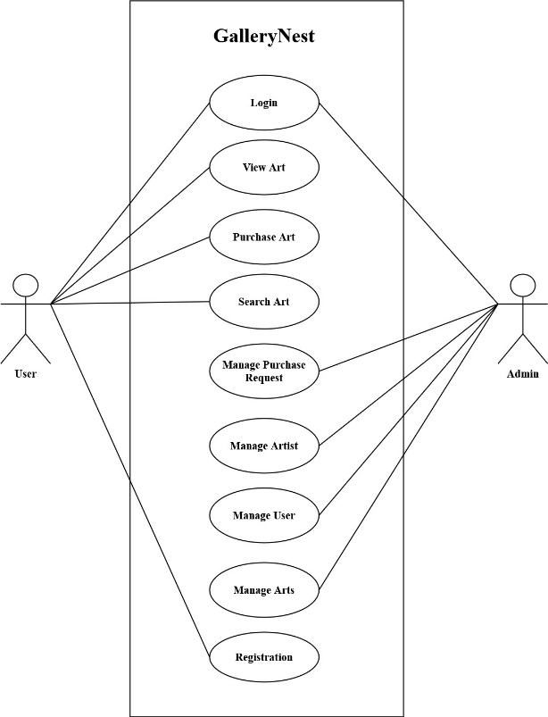
Figure 3.1 Use case diagram of Artmandu

- Artwork Details and Interaction
  - It gives detailed information about each artwork, including title, artist, description, dimensions, and medium is displayed and Users should be able to view high-resolution images of the artworks for a closer look.
- Artwork Enquiries
  - Users should have the ability post enquiries on artworks to share their opinions and engage with seller.
- Filter artworks
  - User can filter artworks on the basis of art detail, artists, art type.
- Adding Artwork
  - Admin user can add artworks to be displayed on the customer portal.
- Admin user Authentication
  - Authentication mechanisms is placed to ensure secure access to admin user account.
- Content modification by Admin
  - Admin user can modify page content of about us and contact details from admin portal.
- Add Artists
  - Admin user can add artists detail to the system to be displayed along with the artwork.

Non-Functional Requirements
- Performance: The website has smooth navigation to provide a seamless user experience, even with a large number of artworks and concurrent users. Response times for browsing, searching, and interacting with artworks is optimal.
- Scalability: The website is designed to handle increasing traffic and a growing database of artworks. It’s able to scale its infrastructure and resources accordingly to ensure consistent performance and user satisfaction
- Security: Robust security measures is implemented to protect user data, secure transactions, and prevent unauthorized access.
- Usability and Accessibility: The website has an intuitive and user-friendly interface, allowing users of varying technical abilities to navigate and interact with the artworks easily.
- Mobile Responsiveness: The website is responsive and optimized for mobile devices, providing a seamless browsing experience across different screen sizes and orientations. The artworks and user interface elements adapts and function well on mobile platforms.

Feasibility Analysis

Technical Feasibility:
The technical feasibility of the online art gallery application was evaluated based on three key factors. Firstly, an assessment of the availability of technology, including required technologies, frameworks, and tools, indicated that all necessary resources were readily accessible for development. Secondly, the development expertise of the team was carefully evaluated, and it was confirmed that the team possessed the essential skills and expertise to build and maintain the application effectively. Lastly, the feasibility analysis showed that integration with third-party systems, such as payment gateways or analytics tools, was feasible and could be achieved seamlessly, enhancing the overall functionality and user experience of the online art gallery.

Economic Feasibility:
The economic feasibility of the online art gallery application was examined through a comprehensive evaluation of three main aspects. Firstly, a cost estimation was conducted to assess the financial resources required for development, hosting, maintenance, security, and marketing of the application. Secondly, potential revenue streams, including artwork sales, advertising, partnerships, and subscription models, were identified and analyzed to determine their capability to sustain operational costs and generate a profit. Lastly, a projected Return on Investment (ROI) was analyzed based on revenue forecasts, taking into consideration factors such as market competition, user adoption rates, and pricing strategies. This economic assessment provided valuable insights into the financial viability of the online art gallery project and its potential for long-term sustainability and profitability.

Operational Feasibility:
The operational feasibility of the online art gallery application was carefully assessed by evaluating two main aspects. Firstly, resource availability was examined to determine if the required human resources, including the development team, content curators, administrators, and customer support, are available or can be acquired. This evaluation ensured that the necessary personnel could effectively manage the different aspects of the platform's operations. Secondly, operational processes were defined and analyzed to ensure efficient and scalable workflows for managing artworks, artist profiles, transactions, customer inquiries, and other day-to-day activities.

Schedule feasibility:
The schedule feasibility of the online art gallery application was carefully evaluated by breaking down the development tasks and estimating the time required for each phase, including requirements gathering, design, development, testing, and deployment. The complexity of the application and the availability of resources were thoroughly considered to ensure a realistic development timeline. Specific milestones and deliverables were defined for each phase of the project, enabling effective progress tracking and ensuring timely completion.

Data Modeling
A data model is a mechanism that provides this abstraction for database application. Data modeling is used for representing entities and their relationship in the database. E-R (Entity Relationship) Model can be referred to as a Data Model. E-R Model is a popular high level conceptual data model. This model and its variations are frequently used for the conceptual design of database application and many database design tools employ its concept. A database that confirms an E-R diagram can be represented by a collection of tables in the relational system.
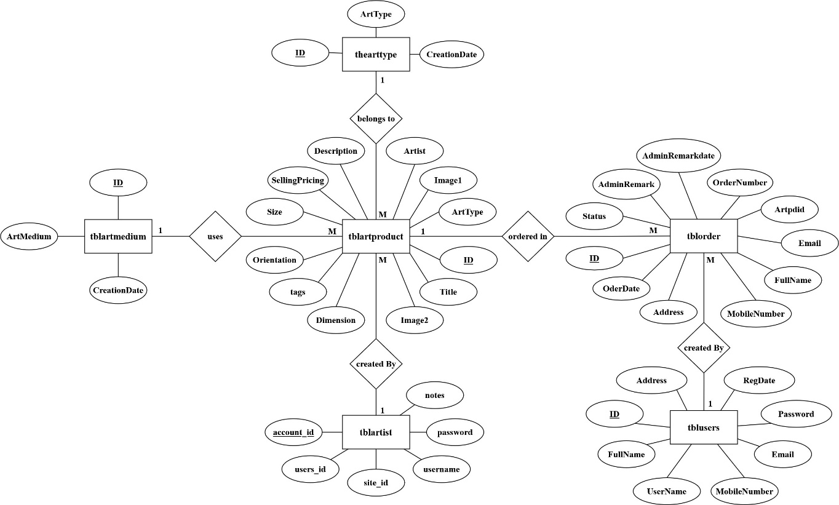
ZFigure 3.2 ER diagram of Artmandu

Process Modeling
A DFD can be referred to as a Process Model. A data-flow diagram (DFD) is a graphical representation of the "flow" of data through an information system. DFDs can also be used for the visualization of data processes (structured design). A data flow diagram (DFD) is a significant modeling technique for analyzing and constructing information processes. DFD illustrates this flow of information in a process based on the inputs and outputs.

DFD 0 Level
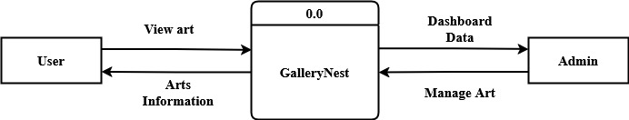
Figure 3.3 DFD level 0

DFD 1 Level
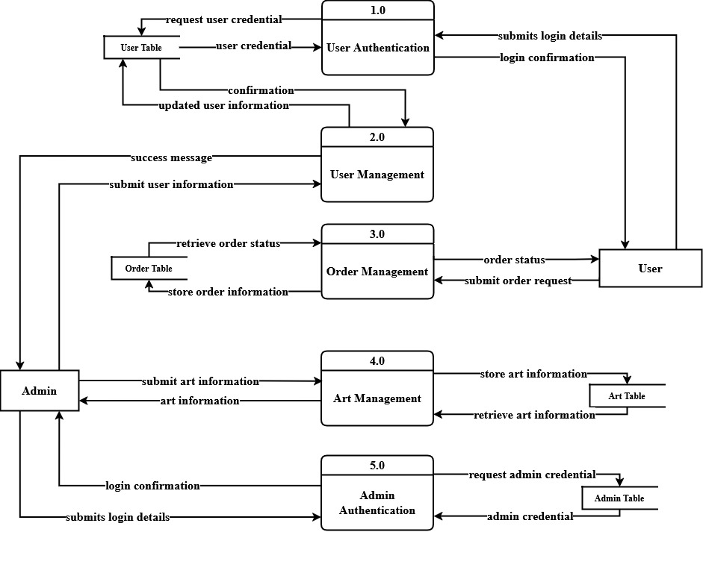
Figure 3.4 DFD Level 1

System Design

Architectural Design
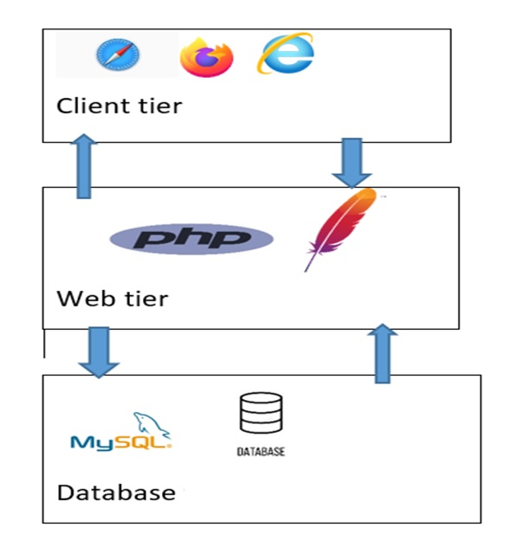
Figure 3.5 System Architecture Design

Client Tier:
This is a Presentation layer which contains the UI of the system. This tier is used for design purposes where data is presented to the user or input is taken from the user through web browsers. Different web browsers can be used. These tiers are usually developed using HTML and CSS.
Web Tier:
This tier acts as an interface between Client tier and Data tier. It helps to make communication faster between Client and Data layer. The application tier can also add, delete, or modify data in the data tier.
Database Tier:
It connects with the database and to perform insert, update, delete operations and to get data from the database based on our input data. This is the tier where the information processed by the system is stored and managed.

Database Schema
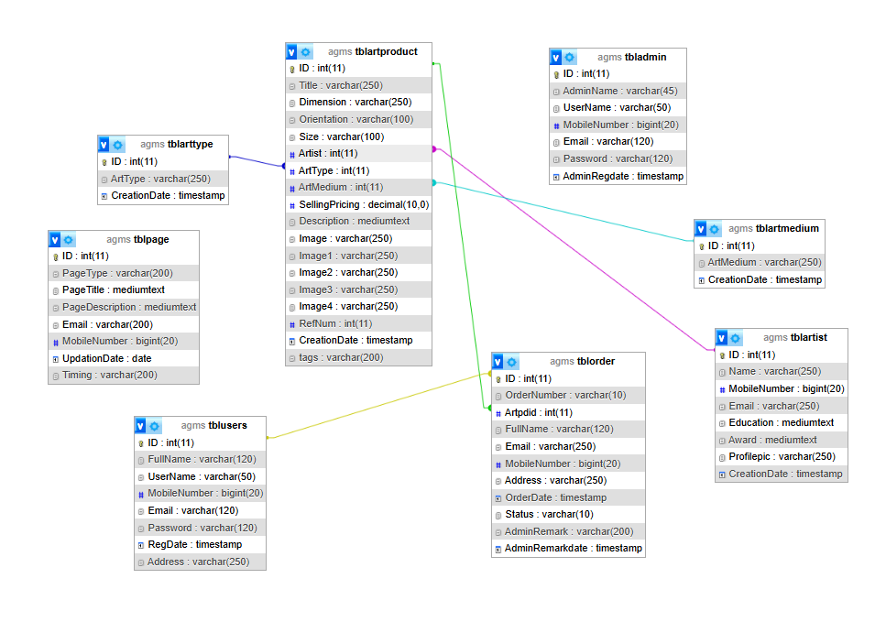

Figure 3.6 Database Schema of Artmandu

Interface design (UI/UX)
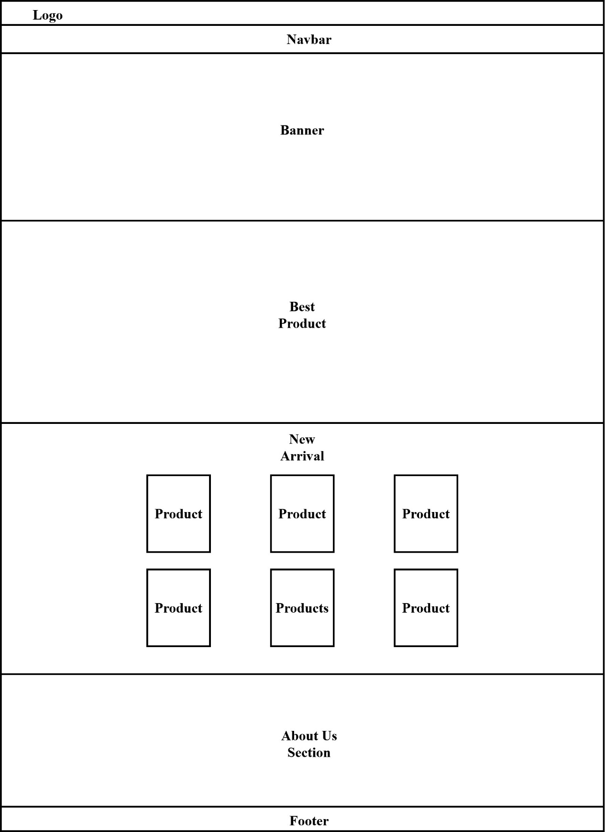
Figure 3.7 Interface Design of Artmandu

Physical DFD
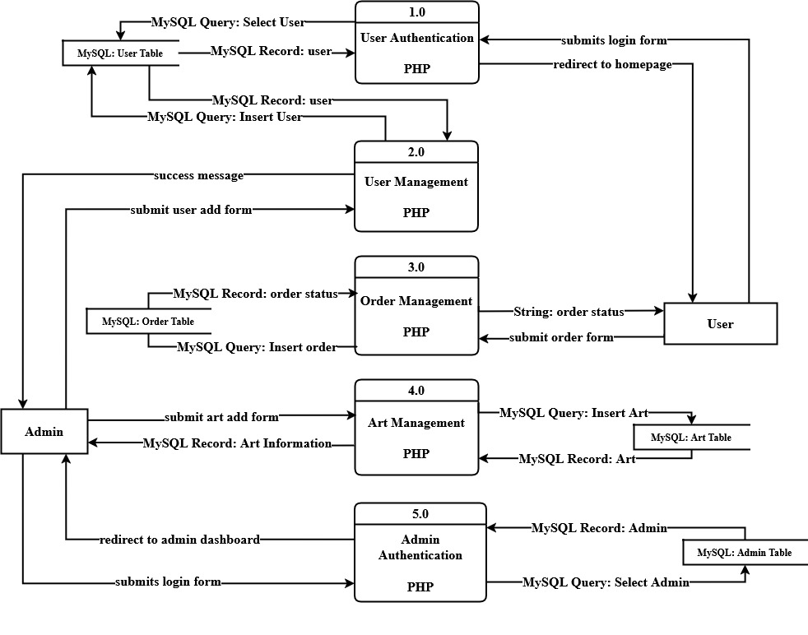
Figure 3.8: Physical DFD of Artmandu

Algorithm Details
- Content-Based Filtering with Cosine Similarity and Weighted Sorting
This algorithm combines three key components to provide personalized artwork recommendations based on product attributes and user preferences.
How It Works
- Purpose: To recommend similar artworks by analyzing product attributes and calculating similarity scores using cosine similarity, then applying weighted sorting for optimal ranking.
- Parameters:
  - productId: Current product being viewed
  - tagData: JSON array of product tags
  - weightFactors: Importance weights for different attributes
  - similarityThreshold: Minimum similarity score (default: 0.1)
- Algorithm Steps:
  - Cosine Similarity Calculation:
cosineSimilarity (A, B) = (A · B) / (||A|| * ||B||)
Where:
      - A, B: Tag vectors for products
      - ·: Dot product
      - || ||: Vector magnitude
  - Weighted Sorting:
weightedScore = Σ (wi * si)
Where:
- wi: Weight for attribute i
- si: Similarity score for attribute i
  - Recommendation Generation:
- For each product pair:
  - Calculate cosine similarity between tag vectors
  - Apply weighted sorting based on:
    - Tag similarity (weight: 0.5)
    - Art type match (weight: 0.3)
    - Medium match (weight: 0.2)
    - If final score exceeds threshold, add to recommendation so
    - Sort by weighted
    - Select top 4 recommendations

- Mathematical Foundation:
- Vector Space Model for tag representation
- Cosine similarity for measuring tag similarity
- Weighted scoring system for multi-attribute ranking

- Output:
- Ordered list of 4 most similar products

- Each recommendation includes:
  - Similarity score
  - Matching attributes
  - Product details
This algorithm is based on the Content-Based Filtering approach, which is a type of recommendation system that uses item features to recommend similar items. The cosine similarity measure is used to calculate the similarity between products based on their tags, while the weighted sorting ensures that multiple attributes are considered in the final recommendation ranking.
The effectiveness of this algorithm is measured by:
- Recommendation relevance
- User engagement with recommended products
- Click-through rates on recommendations
- Purchase conversion rates from recommendations

Implementation and Testing

Tools and Technology used

Front End Technology
- HTML: HTML is used to design the frontend views of this system. HTML is used to create the structure of the web pages, defining the layout, headings, paragraphs, images, and other elements necessary for presenting the artworks and their details.
- CSS: CSS is used for describing the presentation of the front-page including colors, layout, and fonts of the system. CSS is used to style the HTML elements, specifying colors, fonts, margins, paddings, and other visual aspects of the site, ensuring an attractive and visually appealing presentation.
- JavaScript: JavaScript is employed to add dynamic behavior and interactivity to the site. It may be used to implement features such as responsive menus, image sliders, form validation, and more, enhancing the overall user experience.

Back End Technology
- PHP: PHP is the backend technology used to create dynamic content and handle server-side operations on the online art gallery site. It is responsible for processing user requests, interacting with the database, and generating responses to be displayed on the frontend.
- MYSQL: MySQL is used as the relational database management system to store and manage the data related to artworks, user information, tags, and other relevant data for the online art gallery site.

Tools
- VS Code: VS Code is used in this project for its robust code editing capabilities and support for markdown, allowing for efficient and visually appealing documentation of project requirements, design specifications, and technical documentation.
- MS Word: MS Word is used in this project as a powerful word processing tool, enabling the creation, formatting, and organization of project documents with features like headings, tables of contents, media insertion, and collaboration tools for effective document management and review.
- XAMPP: XAMPP is used in this project to provide a local development environment with Apache, MySQL, and PHP facilitating the testing, deployment, and management of the online art gallery application, including the local database management and server-side scripting functionalities.

Module Description
The different modules provided are:
Module 1: admin login
if(isset($_POST['login']))
{
$adminuser=$_POST['username'];
$password=$_POST['password'];
$query=mysqli_query($con,"select * from tbladmin where UserName='$adminuser'");
$ret=mysqli_fetch_array($query);
if(password_verify($password, $ret['Password'])){
$_SESSION['agmsaid']=$ret['ID'];
echo "<script type='text/javascript'> document.location ='dashboard.php'; </script>";
}
else{
echo "<script>alert('Invalid Details');</script>";
}

This PHP snippet processes admin login by checking if the form is submitted, getting the username and MD5-hashed password from the form, and querying the database for a match. If found, it saves the admin's ID in a session and redirects to the dashboard. If not, it shows an "Invalid Details" alert.
Module 2: Manage art product
<?php
$ret=mysqli_query($con,"select *from tblartproduct");
$cnt=1;
while ($row=mysqli_fetch_array($ret)) {
$id = $row['ArtType'];
$query = "SELECT * FROM tblarttype WHERE ID='$id'";
$result = mysqli_query($con, $query);
$arttype=mysqli_fetch_array($result)
?>
<tr>
<td><?php echo $cnt;?></td>
<td><?php echo $row['RefNum'];?></td>

<td><?php echo $row['Title'];?></td>
<td><img src="images/<?php echo $row['Image'];?>" width='100' height="100"></td>
<td><?php echo $row['CreationDate'];?></td>
<td><?php echo $arttype['ArtType'];?></td>
<td><a href="edit-art-product-detail.php?editid=<?php echo $row['ID'];?>" class="btn btn-success">Edit</a> || <a href="manage-art-product.php?delid=<?php echo $row['ID'];?>" class="btn btn-danger">Delete</a></td>
</tr>
<?php

These php code fetches art products from the tblartproduct table and displays them in an HTML table. For each product, it retrieves the corresponding art type from the tblarttype table. The table shows the product's reference number, title, image, creation date, and art type. Each row includes "Edit" and "Delete" buttons for managing the products.

Testing
Testing includes unit testing to ensure individual components function correctly, system testing to validate overall system behavior, and various test cases to cover functionality, performance, and user experience.

Unit Testing
Unit testing involves testing the functionality of individual functions or methods in isolation. While performing unit testing, it focus on verifying the correctness of individual units of code.
- Test Case: Search Artwork by Artist
Test Case Description:
Ensure that the search function correctly retrieves artworks by a specific artist's name.
Test Steps:
- Set up a test artist object with a known name.
- Create a set of test artwork objects with various artists, including the test artist.
- Call the search() function with the test artist's name as the input.
- Verify that the returned list of artworks only includes artworks by the specified artist.
Expected Result:
The search() function successfully filters and retrieves artworks that match the specified artist's name.
- Unit Test Case: Submit Artwork Enquiry

Test Case Description:
Verify that the submitEnquiry() function successfully handles the submission of an enquiry about a specific artwork.

Test Steps:
- Set up a test artwork object with a known ID and other necessary details.
- Create a test user object with relevant information.
- Call the submitEnquiry() function, providing the test user object and the test artwork ID as inputs.
- Verify that the enquiry is successfully submitted and stored in the system.
- Retrieve the submitted enquiry and compare its details with the test user object and the artwork ID.

Expected Result:
The submitEnquiry() function should handle the submission of the enquiry effectively, associating it with the correct user and artwork. The submitted enquiry should be stored and retrievable from the system, matching the provided user details and artwork ID.

System Testing
System testing involves testing the entire system or a significant part of it as an integrated entity. It focus on validating the system behavior and its compliance with functional and non-functional requirements.

System Testing Scenario: Admin Login Process
Admin Login Process
 | Steps | Expected Outcome | Status
Test the user login process to ensure secure authentication and access control within the online art gallery system. | Enter valid login credentials (username and password) for a registered user. | Successful Login | Pass
 | Attempt to log in with invalid or incorrect credentials. | Error Message for invalid login. | Pass

System Testing Scenario: Adding Artwork to the Gallery
Adding Artwork to the Gallery
 | Steps | Expected Outcome | Status
Test the functionality of adding new artwork to the online art gallery, ensuring that the system accurately stores and displays the artwork details. | - Log in to the system as an authenticated user  - Provide all required details for the artwork  - Submit the artwork for upload | Successfully add artwork | Pass
 | Submit with empty field while filling the artwork detail. | Required validation error on specific field. | Pass

Relating Artwork with Artist
 | Steps | Expected Outcome | Status
Test the functionality that associates an artwork with its corresponding artist, ensuring that the relationship is established correctly. | - Create a new artist with a known identifier.  - Associate the artwork with the artist by linking their respective identifiers. | Successfully added art with artist. | Pass
 | Leaving the artist field empty while adding artist | Validation error on artist field. | Pass
System Testing Scenario: Relating Artwork with Artist

Conclusion and Recommendation

Conclusion
In conclusion, the online art gallery project has successfully delivered a user-friendly and comprehensive platform for art enthusiasts to explore, discover, and engage with a wide range of artworks and artists. The project's thorough requirement analysis and implementation of both functional and non-functional requirements have resulted in an intuitive artwork search, secure user authentication, seamless artwork submission, and proper association of artworks with their respective artists. The feasibility analysis has shown that the project is both technically and economically viable, providing a valuable solution for art lovers and supporting the growth of artists. The prioritization of user experience, security, and performance has created an immersive and captivating environment where art enthusiasts can connect with their favorite artworks and artists.

Lesson learnt
Throughout the development process, the project provided valuable lessons. It underscored the importance of taking a structured and organized approach to development, emphasizing thorough planning and requirement analysis. These practices helped avoid potential pitfalls and enabled informed decision-making during the development journey. The outcome of the project was a fully functional and user-friendly online art gallery website that successfully met the needs of art enthusiasts. The website offered a seamless browsing experience, enabling users to easily search, sort, and explore a vast collection of artworks. Artists were able to showcase their work through personalized profiles, fostering engagement and interaction with users.

Future Recommendation
For future recommendations, there are several opportunities to enhance the online art gallery project further. One such recommendation involves, allowing users to create personalized profiles, follow other users or artists, and engage through comments on artworks, the platform can foster meaningful interactions among art lovers, collectors, and creators. These features would create opportunities for discussions, feedback, and the sharing of artistic preferences, turning the platform into a collaborative and interactive space rather than just a transactional one.
Another valuable addition would be providing artists with the ability to create and manage their own portfolios would offer them a dedicated space to showcase their work and artistic journey. This feature would be especially beneficial for emerging or independent artists seeking exposure. Such tools not only give artists greater control and visibility but also offer users a curated and immersive way to explore art. Together, these enhancements would significantly contribute to creating a vibrant, engaging, and community-driven art platform.
By implementing these future recommendations, the online art gallery can evolve into a more dynamic and engaging platform that connects artists and art enthusiasts. It would not only enhance user satisfaction but also contribute to the growth and promotion of the art community.

Reference
[1] | J. Smith, "The Impact of Online Art Galleries on the Art Market," 2022. [Online]. Available: https://www.artworldinsights.com/the-impact-of-online-art-galleries.
[2] | S. Sharma, "The Role of Online Art Galleries in Promoting Nepali Art and Artists," 6 june 2023. [Online]. Available: https://www.nepaliartinsights.com/online-art-galleries-nepal.
[3] | R. Joshi, "Contemporary Art in Nepal," in Exploring the Intersection of Tradition and Modernity, Himalayan Publications, 2018.
[4] | R. Patel, "A Complete Guide on Software Development Process," 23 06 2023. [Online]. Available: https://www.spaceo.ca/blog/software-development-process/.

Appendix
Homepage
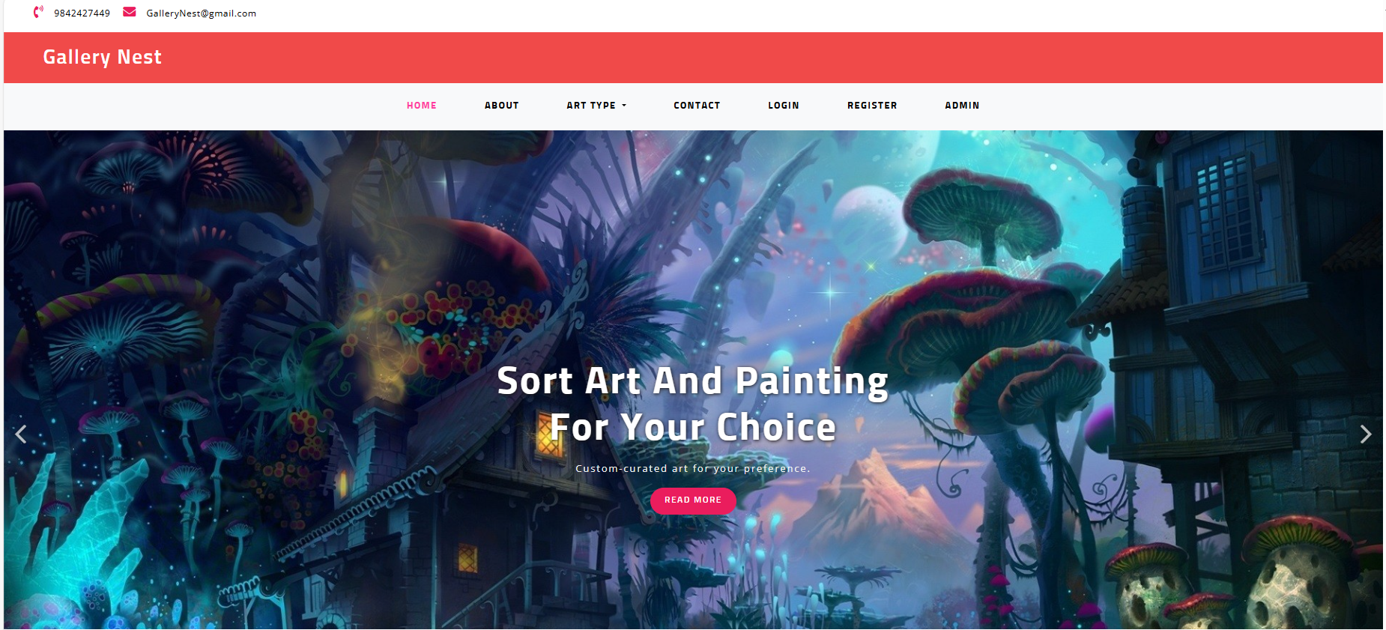

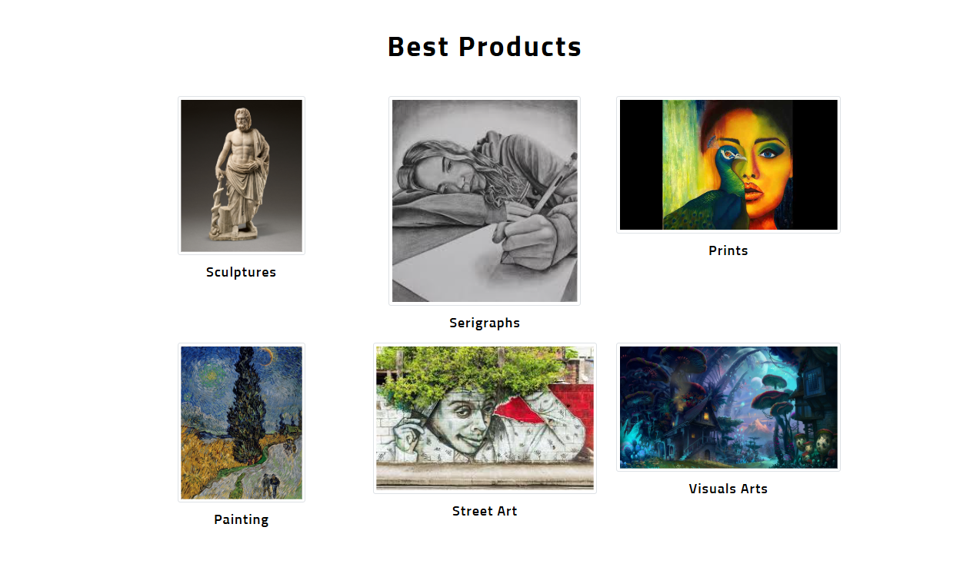

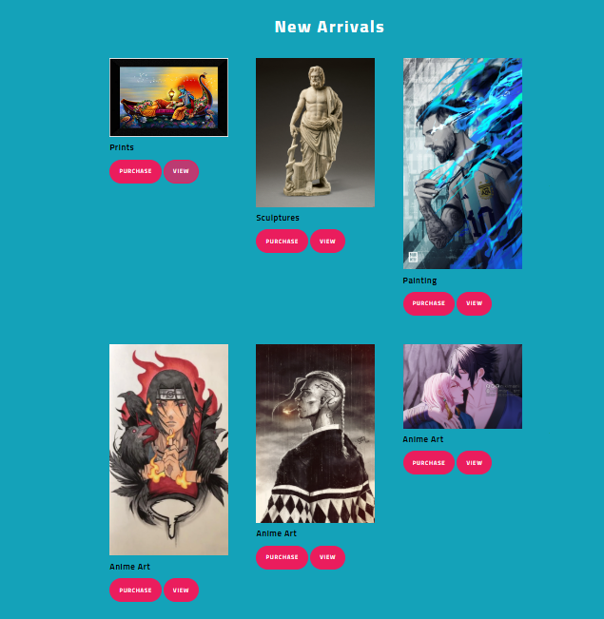

About US page
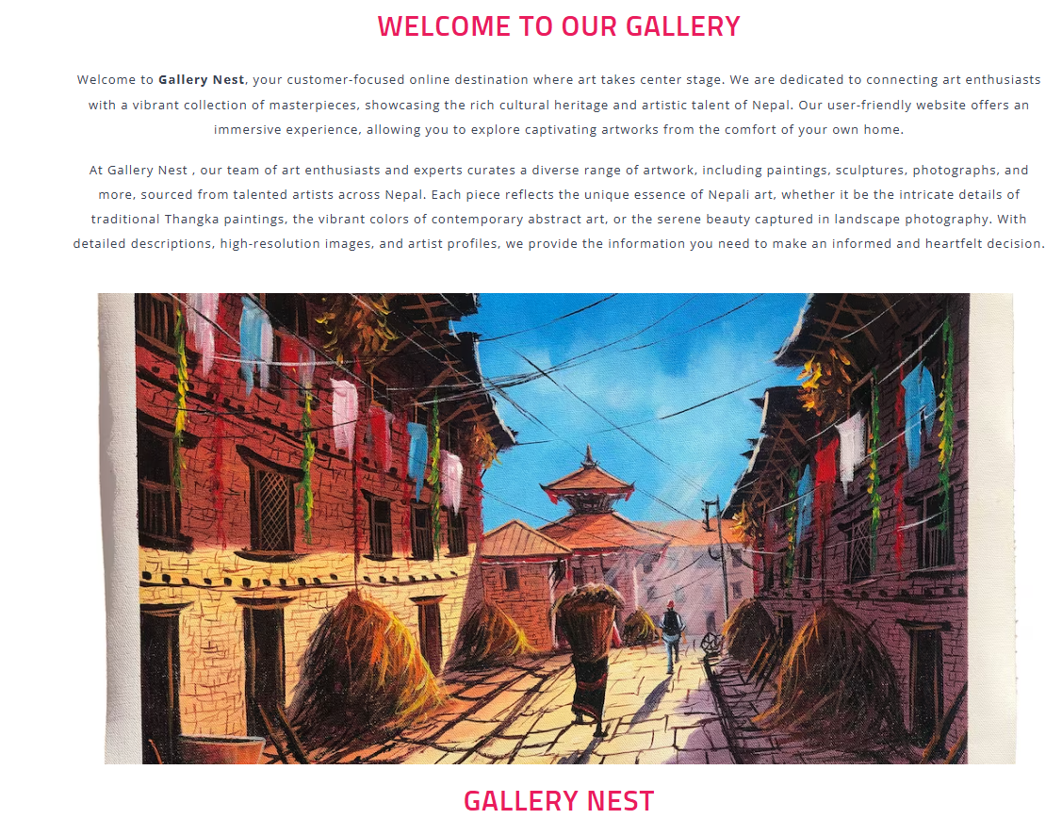

User Login page
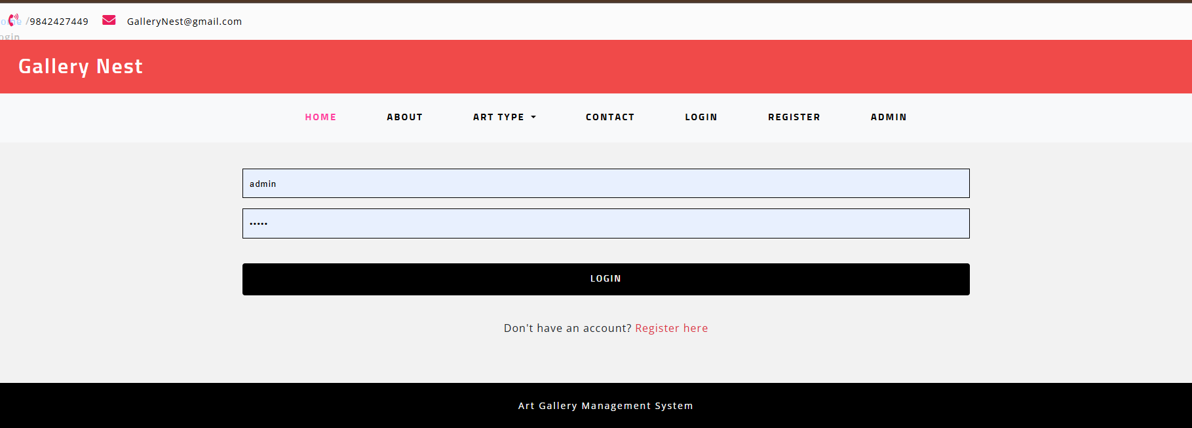

User Registration page
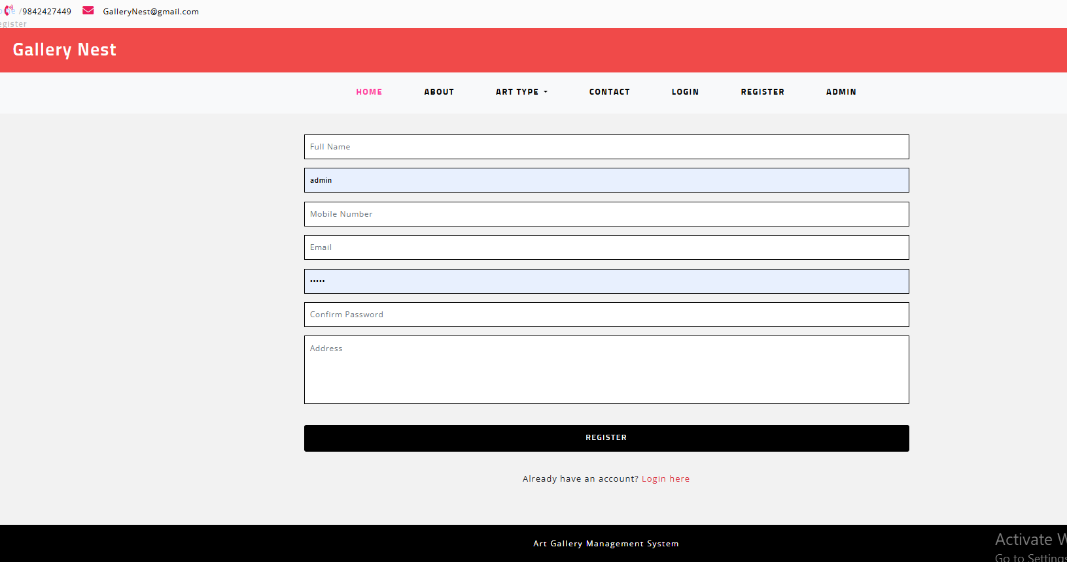

Recommendation
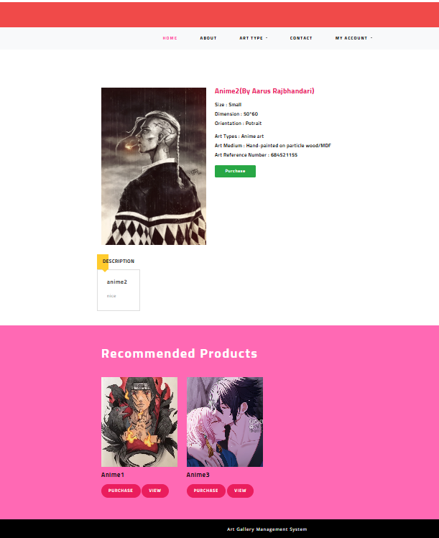

Admin Login

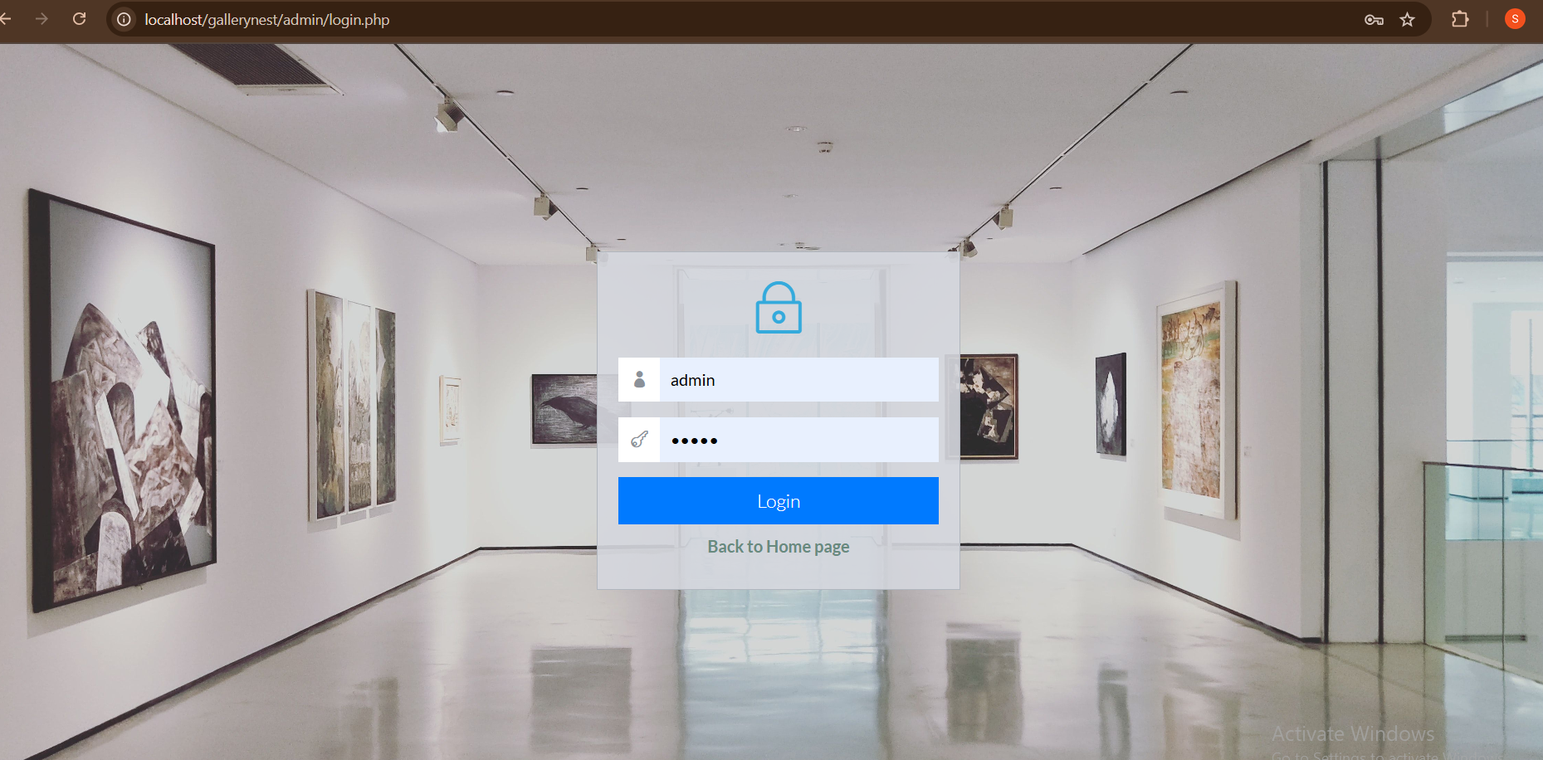

Admin Dashboard

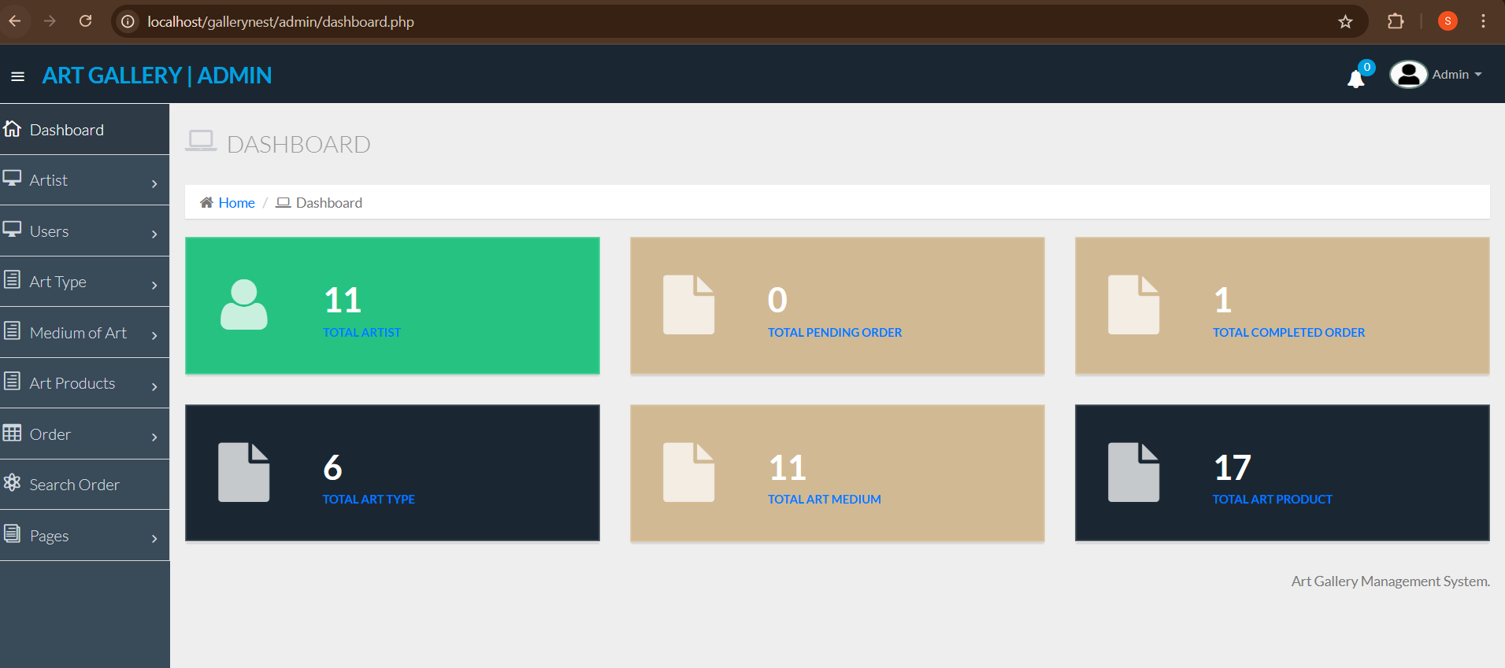

Purchase Artwork

